 | Jaipuria Institute of Management,  Vineet Khand, Gomti Nagar  Lucknow – 226010
Academic Year | 2026-27
Batch | 2025-27
Trimester | 4TH
Programme | PGDM
Name of Course | MACHINE LEARNING
Section | A
Name of Faculty | DR. ANKIT MEHRORTRA
Nature of Submission | GROUP PROJECT REPORT
Topic of Group Assignment / Group Project | ML AI-Assisted Group Project
Deadline for Submission | 7 TH OCTOBER, 2026
Group/ Learning Team Number | LT 07
Maximum Marks Allotted

Tick on appropriate
We hereby declare that this project/assignment does not contain any AI generated content (e.g. ChatGPT etc.)
I We hereby declare that this project/assignment has used AI generated content (e.g. ChatGPT etc.) as supporting resource for the completion of project/assignment.
Contribution of Group/LT members in the Assignment/Project
Sl. No. | Enroll. No. of Student | Name of Student | Contribution | Signature
1 | JL25PG034 | ANSHIKA PANDEY | 16.67% | Anshika
2 | JL25PG053 | AYESHA FATIMA | 16.67% | Ayesha
3 | JL25PG155 | SANTANU GUPTA | 16.67% | Santanu
4 | JL25PG170 | SHAURYA SRIVASTAVA | 16.67% | Shaurya
5 | JL25PG051 | AVINNA ARORA | 16.67% | Avinna
6 | JL25PG016 | AKHIL JAISWAL | 16.67% | Akhil

Table of Contents
Part 1: Business Problem Identification and Dataset Selection 4
1.1 Business Context 5
1.2 Identification of the Business Problem 5
1.3 Business Problem Statement 5
1.4 Project Objective 5
1.5 Dataset Description 5
1.6 Dataset Source 5
1.7 Target Variable 5
1.8 Potential Predictor Variables 6
1.8.1 Variables potentially available before or at order placement 6
1.8.2 Variables that may cause data leakage, or need validation 6
1.9 Why This Dataset Was Selected 6
1.10 Planned Exploratory Data Analysis 6
1.11 Potential Business Questions 7
1.12 Machine Learning Approach 7
1.13 Data Leakage Consideration 7
1.14 Expected Business Solution 7
1.15 Final Justification 7
Part 2: Exploratory Data Analysis and Data Preprocessing 7
2.1 Purpose and Tools Used 8
2.2 Dataset Structure and Data Quality 8
2.3 Target Variable 8
2.4 Univariate Analysis 8
2.5 Bivariate Analysis: Factors vs Late Delivery 8
2.6 Outlier Analysis (IQR Method) 9
2.7 Correlation Analysis 9
2.8 Time-Based Analysis 9
2.9 Data Preprocessing 9
2.10 Key Findings 10
PART 3 – FEATURE SELECTION & MODEL BUILDING 11
3.1 Objective 11
3.2 Preparation of Independent and Dependent Variables 11
3.3 Train-Test Split 11
3.4 Feature Selection and Feature Reduction 12
3.5 Machine Learning Models Selected 13
3.6 Model Building 13
3.7 Initial Model Results 14
3.8 Interpretation of Initial Results 15
3.9 Model Selection for Further Refinement 16
3.10 Part 3 Summary 16
PART 4 – MODEL EVALUATION & REFINEMENT 17
4.1 Objective 17
4.2 Model Evaluation Metrics 17
4.3 Initial Model Comparison 17
4.4 Interpretation of Initial Performance 17
4.5 Model Refinement 18
4.6 Decision Tree Refinement 18
4.7 Random Forest Refinement 19
4.8 Gradient Boosting Refinement 19
4.9 Feature Selection Refinement 19
4.10 Classification Threshold Refinement 20
4.11 Validation and Final Testing 20
4.12 Model Version Tracking 21
4.13 Role of GenAI in Model Refinement 21
4.14 Final Model Selection 21
4.15 Confusion Matrix Interpretation 22
4.16 Key Findings from Model Evaluation 23
4.17 Part 4 Conclusion 23
PART 5 – BUSINESS FINDINGS & FINAL SOLUTION 24
5.1 Objective 24
5.2 Important Features 24
5.3 Business Interpretation of Important Features 25
5.4 Key Business Findings 25
5.5 Business Recommendations 25
5.6 Proposed Deployable Solution 26
5.7 Suggested Dashboard / Business Intelligence View 28
5.8 How the Company Can Use the Model 28
5.9 Limitations 28
5.10 Future Scope 29
5.11 Part 5 Conclusion 29
PART 6 – CONCEPTUAL KNOWLEDGE 30
6.1 Types of Analytics 30
6.2 Exploratory Data Analysis 30
6.3 Classification 30
6.4 Feature Selection 30
6.5 Model Evaluation 30
6.6 Overfitting and Underfitting 30
6.7 Data Leakage 30
6.8 Python Libraries Used in Business Analytics 30
GITHUB Link 31

Part 1: Business Problem Identification and Dataset Selection
Dataset: DataCo Supply Chain

1.1 Business Context
Delivery performance is central to how customers judge a business: every order is a promise to deliver within a stated time. Late deliveries reduce customer satisfaction (complaints, cancellations, switching to competitors), disturb operational efficiency (follow-ups, rescheduling, extra handling), add unplanned costs (expediting, complaint and return handling) and weaken business performance through reputation damage and fewer repeat purchases. Companies therefore want to move from reporting delays to anticipating them.

1.2 Identification of the Business Problem
In the DataCo data, every order line has a shipping mode, a scheduled shipping time and a final outcome showing whether it was delivered late. Normally a late delivery is discovered only after it happens, when little can be done. The problem is to predict whether an order is at risk of being delivered late. Doing this before or at order processing lets the company review the shipping arrangement, prioritise high-risk orders in warehouse and transport planning, and inform the customer in advance. Prediction after delivery has no practical value, so only information available when the order is placed will be used.

1.3 Business Problem Statement
Can the risk of late delivery of an order be predicted using information available at the time the order is placed, so that the company can take preventive action and improve supply-chain performance?

1.4 Project Objective
Main objective: To develop and compare machine learning classification models that predict the risk of late delivery using only information available at or before order processing, and to use the results to recommend ways of improving delivery performance.

1.5 Dataset Description

Item | Description
Dataset name | DataCo Supply Chain Dataset (DataCoSupplyChainDataset.csv)
Rows * columns | 180,519 * 53
Level of detail | One row per order item: 180,519 Order Item Ids, 65,752 Order Ids, 20,652 Customer Ids
Numerical (29: 14 integer, 15 decimal) | e.g. Days for shipping (real), Days for shipment (scheduled), Sales, Order Item Total, Order Item Quantity, Order Item Discount, Product Price, Benefit per order, Order Profit Per Order, Latitude, Longitude. Several (Order Id, Customer Id, Category Id, Department Id) are identifiers, not measurements
Categorical/Text (24, stored as text, including 2 date fields that will be converted to datetime) | e.g. Type (payment type), Shipping Mode, Customer Segment, Market, Order Region, Order Country, Category Name, Department Name, Product Name, Order Status, Delivery Status
Date/time (2, stored as text; to be converted) | order date (DateOrders) and shipping date (DateOrders); order dates run from 1 January 2015 to 31 January 2018
Target variable | Late_delivery_risk (integer, 0 or 1)

Other important characteristics
- Missing values: Product Description is completely empty (180,519 missing); Order Zipcode is missing in 155,679 rows (about 86.2%); Customer Zipcode has 3 missing and Customer Lname 8.
- Duplicates and constant columns: No fully duplicated rows were found. Product Status has one value, and Customer Email and Customer Password each hold a single masked value; these will be dropped.
- Identifiers and inconsistencies: Name, street and similar fields carry no predictive meaning and raise privacy concerns. Customer Country has only two values ('EE. UU.' and 'Puerto Rico'), so its labelling will be checked in EDA.
- Scope: 118 products, 50 categories, 11 departments (e.g. Fan Shop, Apparel, Golf, Footwear); 5 markets (LATAM, Europe, Pacific Asia, USCA, Africa), 23 order regions and 164 order countries.

1.6 Dataset Source
"DataCo SMART SUPPLY CHAIN FOR BIG DATA ANALYSIS" - https://data.mendeley.com/datasets/8gx2fvg2k6/5

1.7 Target Variable
Late_delivery_risk shows whether an order line was delivered late (1) or not (0).
Value | Meaning | Rows | Share
1 | Late delivery risk (order was late) | 98,977 | 54.8%
0 | No late delivery | 81,542 | 45.2%

Every row with Delivery Status = 'Late delivery' has the value 1; rows with 'Advance shipping' (41,592), 'Shipping on time' (32,196) or 'Shipping cancelled' (7,754) all have 0. Why it is suitable: it is already in the dataset, clearly defined, directly relevant to the business problem, has no missing values and its classes are reasonably balanced. With two possible outcomes, this is a binary classification problem.

1.8 Potential Predictor Variables

1.8.1 Variables potentially available before or at order placement
Category | Variables
Order information | Type (payment type), Order Item Quantity, order date (and month, weekday, hour created from it)
Customer information | Customer Segment, Customer City, State, Country (Customer Id only as a grouping field)
Product information | Category Name, Department Name, Product Name, Product Price
Sales and financial | Sales, Order Item Total, Sales per customer, Order Item Discount, Discount Rate, Order Item Product Price
Shipping information | Shipping Mode, Days for shipment (scheduled)
Geographic information | Market, Order Region, Order Country, Order State, Order City
Customer segment | Customer Segment (Consumer, Corporate, Home Office)

Days for shipment (scheduled) matches Shipping Mode exactly in this file (Same Day = 0, First Class = 1, Second Class = 2, Standard Class = 4), so only one may be needed. Order Zipcode is mostly missing and will probably be dropped; Latitude and Longitude will be reviewed in EDA before use.

1.8.2 Variables that may cause data leakage, or need validation
Variable | Why it is a concern | Decision
Delivery Status | Describes the outcome; almost a copy of the target | Exclude
Days for shipping (real) | Actual shipping time, known only after shipment | Exclude
shipping date (DateOrders) | Actual shipping date, known only after processing | Exclude
Order Status | Records how the order ended (e.g. COMPLETE, CANCELED); may change after order placement | Exclude unless shown to be known at order time
Benefit per order, Order Profit Per Order, Order Item Profit Ratio | May be calculated after fulfilment; timing not stated | Validate; exclude if unsure

Late_delivery_risk agrees with 'real shipping days greater than scheduled days' in about 97.5% of rows, which is why actual shipping time cannot be a predictor.

1.9 Why This Dataset Was Selected
- Large number of observations: 180,519 rows allow reliable training, validation and testing of several models.
- Numerical and categorical variables: 29 numerical and 22 text columns give scope for encoding, scaling and feature engineering.
- Missing values and data-quality issues: an empty column, a mostly missing column, a few missing values, constant columns and identifiers support real preprocessing work.
- EDA and outlier scope: sales, discount, profit and quantity columns suit histograms, boxplots and the IQR method.
- Time-based analysis: order and shipping dates span January 2015 to January 2018.
- Business relevance: late delivery is a real, costly logistics problem with a clearly defined target.
- Machine learning suitability: a ready binary target with fairly balanced classes suits several classifiers.
- Feature selection: overlapping columns (duplicated IDs, price and location fields) and the leakage columns require careful judgement.
- Actionable recommendations: results link to shipping mode, market, region, product category and customer segment, which the business can act on.

1.10 Planned Exploratory Data Analysis
- A. Dataset structure: shape, data types, descriptive statistics; convert the two date columns.
- B. Data quality: missing values and percentages, duplicate records (also at Order Id level), inconsistent values such as country labels.
- C. Univariate analysis: histograms and boxplots for numerical variables; frequency tables and bar charts for categorical ones (Shipping Mode, Market, Customer Segment, Department Name).
- D. Bivariate analysis: share of late orders by each categorical predictor; numerical predictors compared across the two target classes.
- E. Outlier analysis: IQR method with boxplots; business interpretation of extreme values (very large orders, unusual discounts) before keeping, capping or removing them.
- F. Correlation analysis: correlation matrix and heatmap to find redundant pairs (e.g. Sales and Order Item Total).
- G. Time-based analysis: order volumes and late-delivery share over time, using the order date.
- H. Business-oriented analysis: late delivery by Shipping Mode, Market, Order Region, Customer Segment, Department/Category and payment Type, and its link with scheduled shipping days. Actual shipping days will be studied only to understand the data, not to build the model.

1.11 Potential Business Questions
- Which factors are most strongly associated with late deliveries?
- Does late-delivery risk differ across shipping modes?
- Do customer segments (Consumer, Corporate, Home Office) differ in late deliveries?
- Which markets and regions have the highest share of late deliveries?
- Are some product categories or departments more likely to be late?
- Do quantity, order value or discount level relate to late-delivery risk?
- Does the risk change with the month, weekday or year of the order?
- How accurately can a model identify high-risk orders using only information available at order placement?

1.12 Machine Learning Approach
This is a supervised binary classification problem. After a train-test split, the planned models are Logistic Regression (simple, explainable baseline), Decision Tree (interpretable rules), Random Forest (ensemble with feature importance) and Gradient Boosting . They will be compared on accuracy, precision, recall, F1-score and ROC-AUC. No modelling is done in Part 1.

1.13 Data Leakage Consideration
Supply-chain columns are often filled in as the order moves through the process. Actual shipping duration, shipping date and delivery status are known only after shipment, so a model using them would look very accurate in training but fail in real use. This is data leakage. The flagged columns are Delivery Status, Days for shipping (real), shipping date (DateOrders) and Order Status, with Benefit per order, Order Profit Per Order and Order Item Profit Ratio to be validated (Section 8.2). Delivery Status is the most dangerous because the target can be read directly from it. The final model will use only information realistically available before or at order processing.

1.14 Expected Business Solution
The final model can work as an early-warning tool that gives each new order a late-delivery risk flag. It could help the company to identify high-risk orders at processing time, prioritise high-risk shipments, improve logistics planning for risky markets, regions or shipping modes, take preventive action, communicate realistically with customers, and so reduce late deliveries and improve satisfaction. The size of any improvement will be known only after the model is built and tested.

1.15 Final Justification
DataCo Supply Chain is the best choice among the five datasets considered because it combines scale, variety and a ready target in one realistic business problem. With 180,519 rows and 53 columns, it has far more features than any other dataset on the shortlist, while Online Retail, the only larger dataset by row count, has just 8 columns and no ready target. The target, Late_delivery_risk, is already defined, has two fairly balanced classes and links directly to a practical logistics question. The data also has missing values, outliers to examine, dates for time-based analysis and a good mix of numerical and categorical variables. In addition, the careful handling of leakage columns such as Delivery Status and actual shipping days adds analytical judgement, and the findings can be turned into specific recommendations on shipping modes, markets, products and customer segments.

Part 2: Exploratory Data Analysis and Data Preprocessing

2.1 Purpose and Tools Used
EDA means studying the data before building any model: what it contains, how clean it is and which patterns are linked to late delivery. Preprocessing then prepares the data for modelling. Both steps were done in a Jupyter Notebook using pandas (loading, summaries, cross-tabulations), NumPy (calculations), and Matplotlib and Seaborn (charts). All numbers below come from the executed notebook.

2.2 Dataset Structure and Data Quality
The file has 180,519 rows and 53 columns (29 numerical, 22 text and 2 date columns stored as text). Key numerical variables are summarised below.
Variable | Mean | Median | Min | Max
Days for shipping (real) | 3.50 | 3 | 0 | 6
Days for shipment (scheduled) | 2.93 | 4 | 0 | 4
Sales | 203.77 | 199.92 | 9.99 | 1,999.99
Benefit per order | 21.97 | 31.52 | -4,274.98 | 911.80
Order Item Quantity | 2.13 | 1 | 1 | 5

- Missing values: Product Description is 100% missing (180,519), Order Zipcode 86.24% (155,679), Customer Lname 8 and Customer Zipcode 3. All other columns are complete.
- Duplicates: none (0 duplicate rows).
- Inconsistencies: Customer Email and Customer Password hold one masked value in every row; Customer Country has only two labels, "EE. UU." and "Puerto Rico". Benefit per order falls as low as -4,274.98 (a large loss on some orders).

2.3 Target Variable
98,977 orders (54.83%) are late and 81,542 (45.17%) are not late. The classes are fairly balanced, so no heavy resampling is expected; precision, recall and F1-score will still be reported with accuracy.

2.4 Univariate Analysis
- Shipping Mode: Standard Class 107,752, Second Class 35,216, First Class 27,814, Same Day 9,737. Customer Segment: Consumer 93,504, Corporate 54,789, Home Office 32,226.
- Market: LATAM 51,594, Europe 50,252, Pacific Asia 41,260, USCA 25,799, Africa 11,614. Quantity: 99,134 orders have quantity 1; quantities 2 to 5 have about 20,300 to 20,400 orders each.
- Sales: 75% of orders are 299.95 or less, with a long tail of high-value orders up to 1,999.99.

2.5 Bivariate Analysis: Factors vs Late Delivery
The table compares the highest and lowest late-delivery rates within each factor. A big gap means the factor separates late and on-time orders well.
Factor | Highest late rate | Lowest late rate | Gap
Shipping Mode | First Class 95.32% | Standard Class 38.07% | 57.25 pts
Product Category | Golf Bags & Carts 68.85% | Men's Golf Clubs 47.70% | 21.15 pts
Order Region | Central Africa 57.96% | Canada 48.80% | 9.16 pts
Payment Type | Payment 57.53% | Transfer 48.54% | 8.99 pts
Year | 2018: 56.29% | 2017: 54.45% | 1.84 pts
Month | August 55.79% | July 54.06% | 1.74 pts
Market | Europe 55.21% | LATAM 54.36% | 0.85 pts
Customer Segment | Home Office 55.07% | Corporate 54.72% | 0.35 pts

- Shipping Mode is by far the strongest factor. Faster modes (First Class, Second Class) are late more often, probably because they promise very short delivery windows. This needs to be tested further.
- Category, region and payment type show moderate differences. Golf Bags & Carts has only 61 orders, so its extreme rate should be read carefully. Transfer orders are less often late (48.54%), which is worth testing in the models.
- Segment, market, month and year are almost flat (all close to the overall 54.83%), so they are weak predictors alone. Average Sales is also nearly the same for late (203.34) and not-late (204.29) orders.
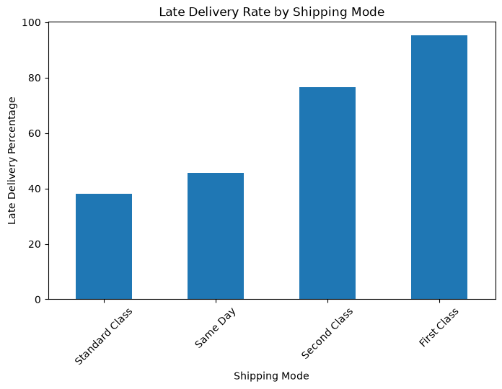  Figure 1: Late delivery rate by shipping mode | 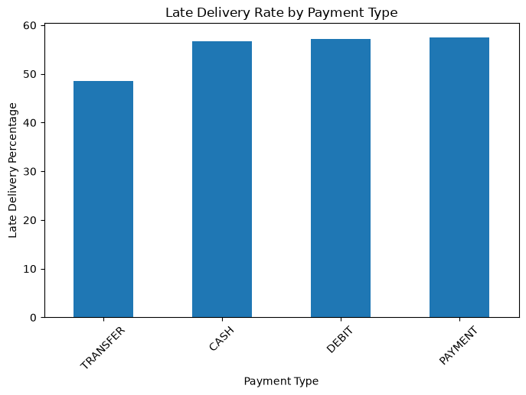  Figure 2: Late delivery rate by payment type

2.6 Outlier Analysis (IQR Method)
For Sales, the IQR limits are -149.98 and 569.91. No order is below the lower limit, and 488 orders (0.27%) are above the upper limit. These look like expensive products and not data errors, so they are not deleted blindly. They can be kept (tree-based models handle them well) or capped, and this will be decided during modelling.

2.7 Correlation Analysis
Sales and Order Item Total are almost identical (0.99), so one of them is redundant. Late_delivery_risk has a correlation of 0.40 with Days for shipping (real) and -0.37 with Days for shipment (scheduled); for every other numerical variable it is very close to zero (0.014 or less in size). The real shipping days column is only known after delivery, which confirms the leakage concern from Part 1.

2.8 Time-Based Analysis
Orders per year were 62,650 (2015), 62,550 (2016), 53,196 (2017) and 2,123 (2018, only January). The late-delivery rate stays steady at about 54% to 56% (54.86%, 55.07%, 54.45% and 56.29%); the 2018 figure rests on very few orders. The monthly rate also stays between 54.06% and 55.79%, so no clear seasonal pattern is visible. The order date will still be used to create month and weekday features.
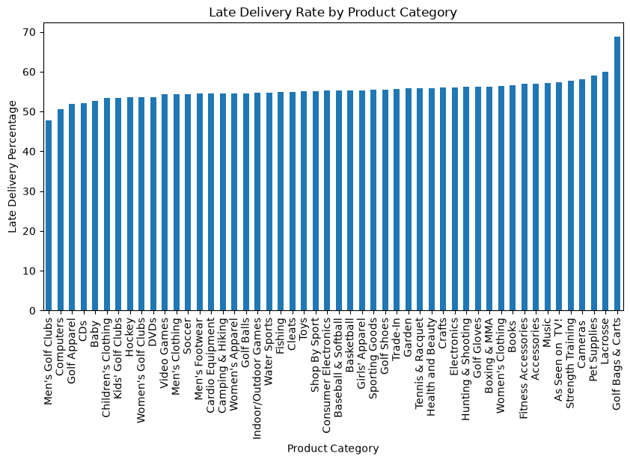  Figure 3: Late delivery rate by product category | 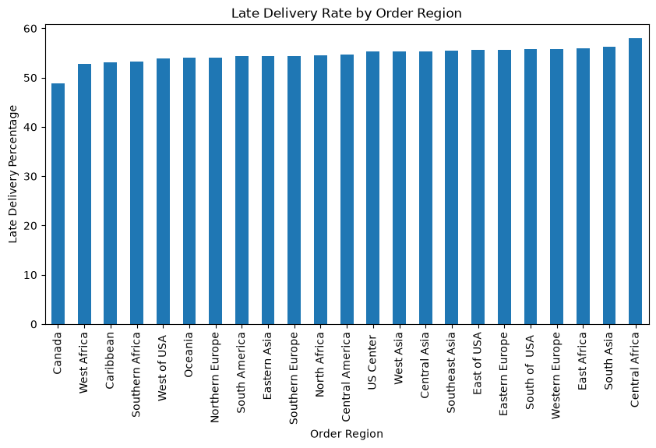  Figure 4: Late delivery rate by order region

2.9 Data Preprocessing
Preprocessing was done on a fresh copy of the data (df_model) so that the original data used for EDA stays unchanged.
Step | Action taken | Reason
1. Date features | Year, month, day and weekday created from the order date | Allows time patterns to be used by the models
2. Drop columns (27) | Product Description, Order Zipcode, Product Status, Customer Email, Password, first name, last name and street; all ID columns (Customer, Order, Item, Product, Category, Department); original date columns | Empty, mostly missing, constant, personal or ID columns carry no predictive value
3. Remove leakage | Delivery Status, Days for shipping (real), shipping date, Order Status | Known only after the order is delivered
4. Remove other risky or redundant | Benefit per order, Order Profit Per Order, Order Item Profit Ratio, Order Item Total | Profit timing is uncertain; Order Item Total duplicates Sales
5. Missing values | Remaining 3 missing values (Customer Zipcode) filled with the median; code also fills text columns with the mode | Leaves 0 missing values
6. Encoding | One-hot encoding (drop_first = True) on 15 text columns | Models need numerical input

After dropping columns, 31 columns remained, and the target keeps its original counts (98,977 late, 81,542 not late). Limitation: one-hot encoding of high-cardinality columns such as Order City (3,597 values), Order State (1,089) and Customer City (563) creates a very large number of columns (about 5,800 in total), so feature selection must reduce them later. Product Name and Product Image both have 118 values and appear to repeat the same information. Scaling and the train-test split will follow before modelling.

2.10 Key Findings
- Shipping mode is the main driver of late delivery; category, region and payment type add smaller differences, while segment, market and time are weak.
- The data is clean enough for modelling after dropping unusable columns, and the target is fairly balanced.
- Only information known at order time is kept, so the model can be used for real prevention in the next stage.

PART 3 – FEATURE SELECTION & MODEL BUILDING

3.1 Objective
The purpose of Part 3 is to turn the cleaned and encoded dataset from Part 2 into a modelling dataset and build the first set of classification models. This part covers separating X and y, splitting the data into training and testing sets, selecting relevant features, and building four models: Logistic Regression, Decision Tree, Random Forest and Gradient Boosting.
The business question is: can DataCo tell, at the time an order is placed, whether it is at risk of being delivered late?

3.2 Preparation of Independent and Dependent Variables
- Target variable (y): Late_delivery_risk, where 1 = late delivery and 0 = not late. Across the full data, 54.83% of rows are late and 45.17% are not late.
- Independent variables (X): all other columns that are known when the order is placed, after the Part 2 cleaning and encoding. The target column was removed from X.
- Size after Part 2 encoding: the encoded data (df_model) had 180,519 rows and 5,798 columns, which means 5,797 features plus the target.
- Type of problem: because the target has only two outcomes (late / not late), this is a binary classification problem.

3.3 Train-Test Split
The data is divided into a training set, on which the model learns, and a test set of unseen orders, which shows how the model is likely to perform on new orders. Without a separate test set, the score would only show how well the model remembers the data it has already seen.
In this dataset one row is one order item, and one order can contain several items. The notebook showed that there are 65,752 orders in 180,519 rows (about 2.75 items per order), and that all items of one order have the same target value. A random row-wise split would therefore place items of the same order in both training and test data. The model would see the answer for that order during training, and the test score would look better than it really is. This is data leakage.
To avoid this, the order IDs were split 80/20 (random_state = 42) and all items of an order were kept on the same side. Order Id was used only to create the split and is not a feature.
Item | Value
Total rows (order items) | 180,519
Total orders | 65,752
Training observations (80% of orders) | 144,305
Test observations (20% of orders) | 36,214
Late share – training data | 54.87%
Late share – test data | 54.65%

The late share is almost the same in both sets, so the test set represents the training data well. Because the classes are about 55/45, they are close to balanced, so SMOTE or class weights were not used. Precision, recall and F1 for the late class are still read along with accuracy.
Scaling: Logistic Regression works better when features are on a similar scale, so a StandardScaler was fitted on the training data only and then applied to the test data. The tree-based models do not need scaling and used the raw data.

3.4 Feature Selection and Feature Reduction
One-hot encoding in Part 2 created 5,797 feature columns, mostly from text columns with very many different values. Features were reduced in two steps. Step 1 (below) removed columns that do not help. Step 2 (Section 3.9) used Random Forest feature importance to pick the top 20 features, which were tested as a smaller model in Part 4.
Stage | Action | Features left
After Part 2 encoding | Starting point | 5,797
Removed dummy columns of high-cardinality / repeated text columns | Order City (3,596 dummies), Order State (1,088), Order Country (163), Customer City (562), Customer State (45), Product Name (117), Product Image (117) | 109
Removed 4 other columns | Customer Zipcode, Order Item Product Price, Sales per customer, Days for shipment (scheduled) | 105
Step 2 (Part 4 refinement) | Top 20 features by Random Forest importance | 20

Why these columns were removed:
- Order City (3,597 values), Order State (1,089), Customer City (563) and Order Country (164) create most of the 5,797 columns. Each value covers only a small slice of the orders, so the model would memorise places instead of learning a general pattern. Location is still described by Market, Order Region, Latitude and Longitude.
- Customer State (46 values) – the customer's location is already described by Latitude and Longitude.
- Product Name and Product Image – every product has exactly one image, so both carry the same information. The product group is already described by Category Name and Department Name.
- Days for shipment (scheduled) – each shipping mode has exactly one scheduled value (Same Day 0, First Class 1, Second Class 2, Standard Class 4), so it repeats the information in Shipping Mode.
- Order Item Product Price is a copy of Product Price (correlation 1.0), and Sales per customer is a copy of Order Item Total (correlation 1.0), which Part 2 had already dropped as a near-copy of Sales.
- Customer Zipcode is a postal code stored as a number. A bigger zipcode does not mean "more" of anything.
Leakage prevention: (1) X contains only information available when the order is placed
(2) the split was done by order, not by row
(3) Order Id was not used as a feature
(4) the scaler was fitted on training data only
(5) feature importance was calculated on training data only
(6) a separate validation set was used in Part 4 so that the test set stayed untouched until the end.
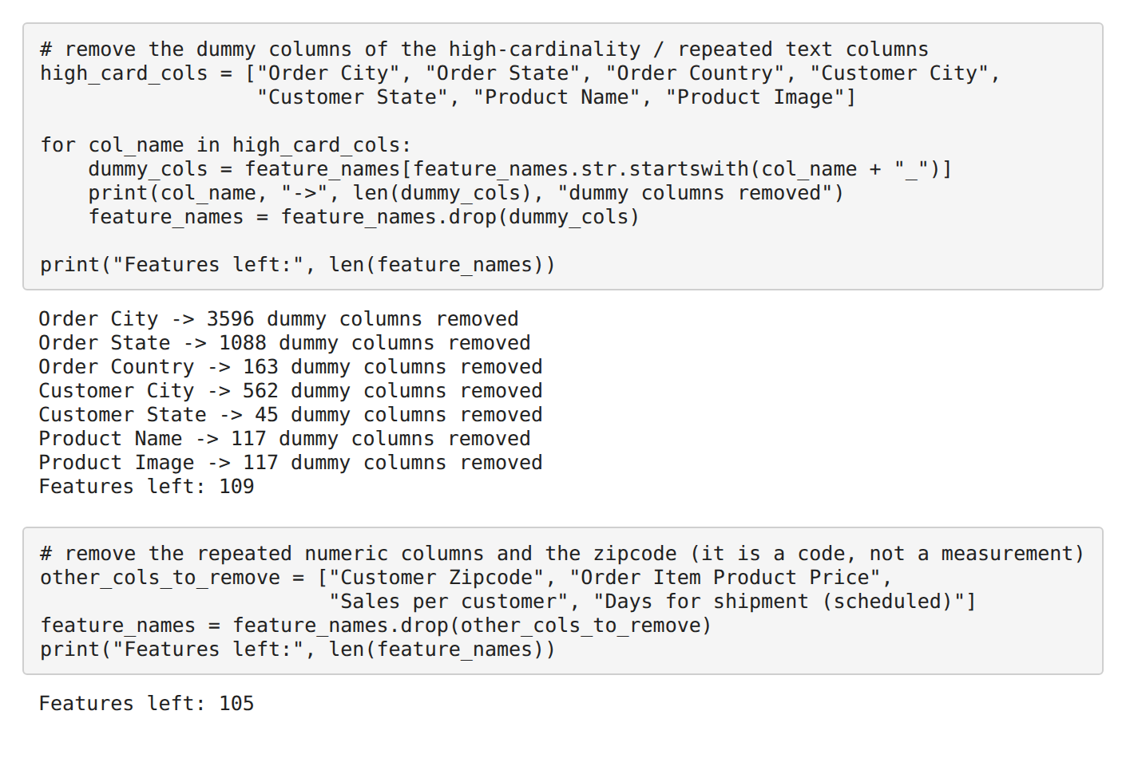

3.5 Machine Learning Models Selected
Four classification models were selected, moving from a simple baseline to more powerful ensemble models.
Model | What it does | Why suitable here | Main advantage
Logistic Regression | Estimates the probability that an order is late using a weighted combination of the features. | Simple and fast for a late / not-late outcome; gives a baseline that other models must beat. | Easy to explain to non-technical managers.
Decision Tree | Learns a set of if-then rules (for example, if shipping mode is First Class then late). | Handles 0/1 dummy columns and numeric columns together without scaling. | Rules are easy for operations teams to read.
Random Forest | Builds many decision trees and combines their predictions (ensemble). | Averaging many trees reduces the overfitting of a single tree. | Gives a feature importance ranking used for feature selection.
Gradient Boosting | Builds trees one after another, each trying to reduce the remaining error of the earlier trees. | Usually performs well on table-type business data with a mix of numeric and category columns. | Often strong at ranking risky orders above safe ones.

3.6 Model Building
All four models were trained on the 144,305 training observations (105 selected features) and then used to predict the 36,214 test orders. Logistic Regression used the scaled data (max_iter = 1000). The Decision Tree, Random Forest (100 trees) and Gradient Boosting used the raw data with default settings and random_state = 42. For each model the notebook produced the confusion matrix, classification report and AUC. The full code is in the notebook.

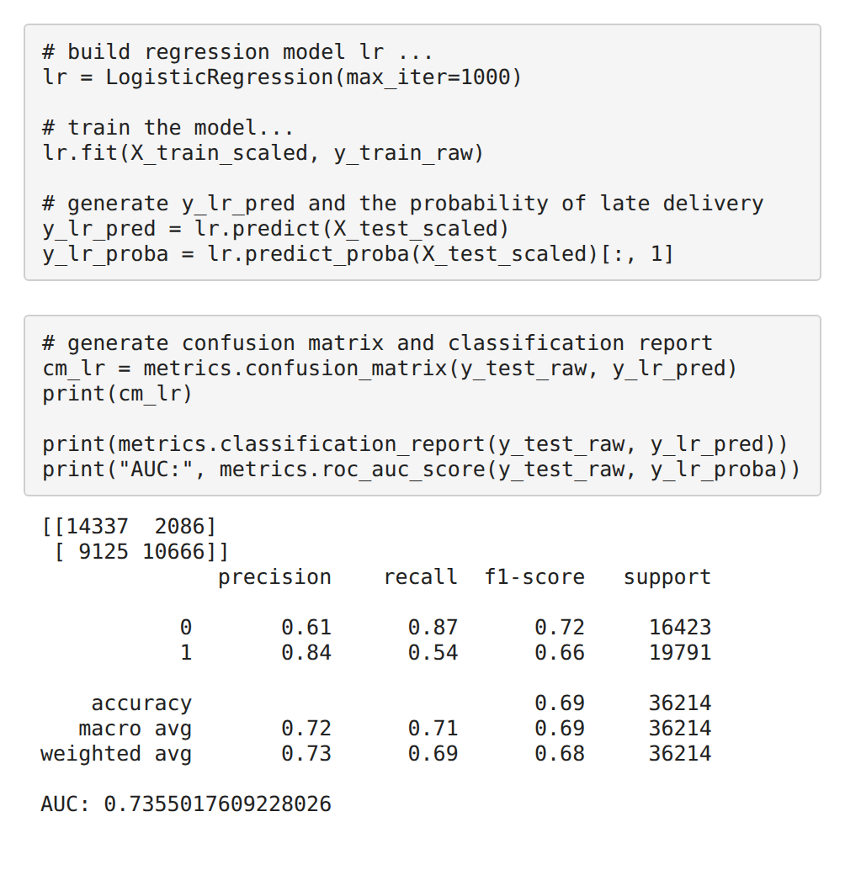 | 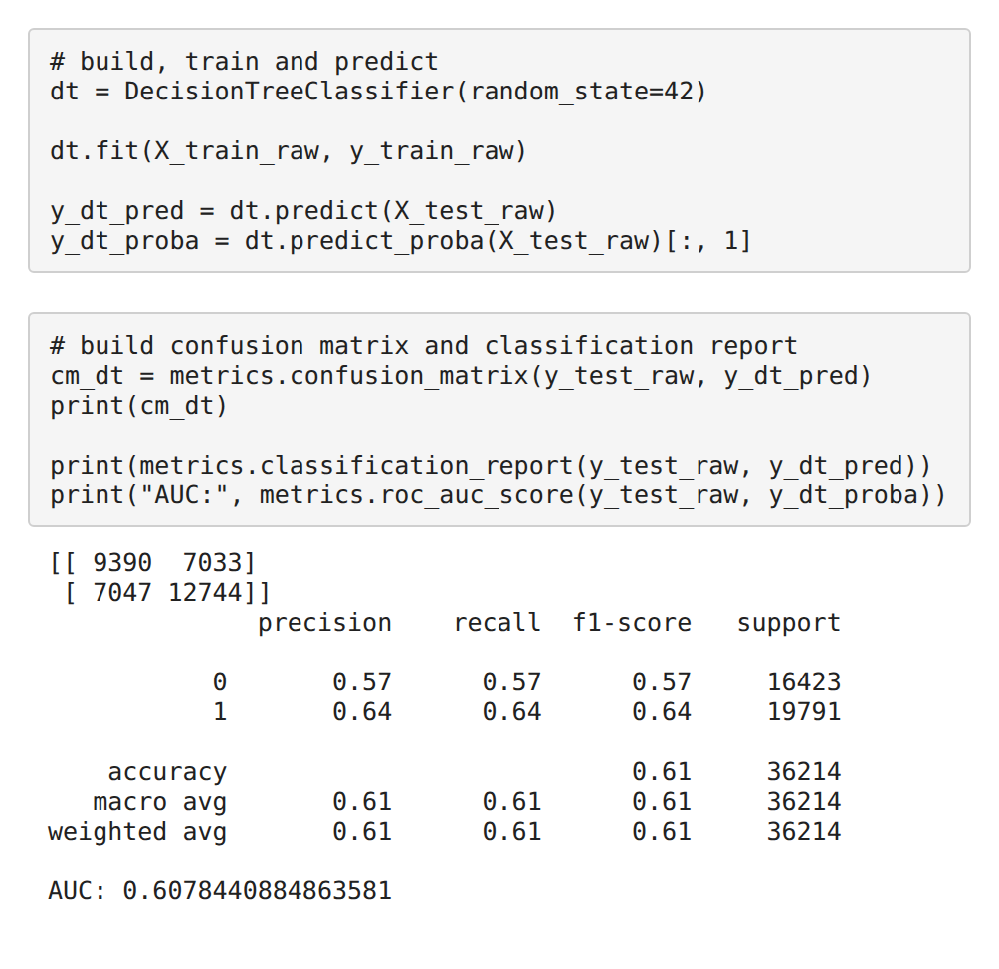
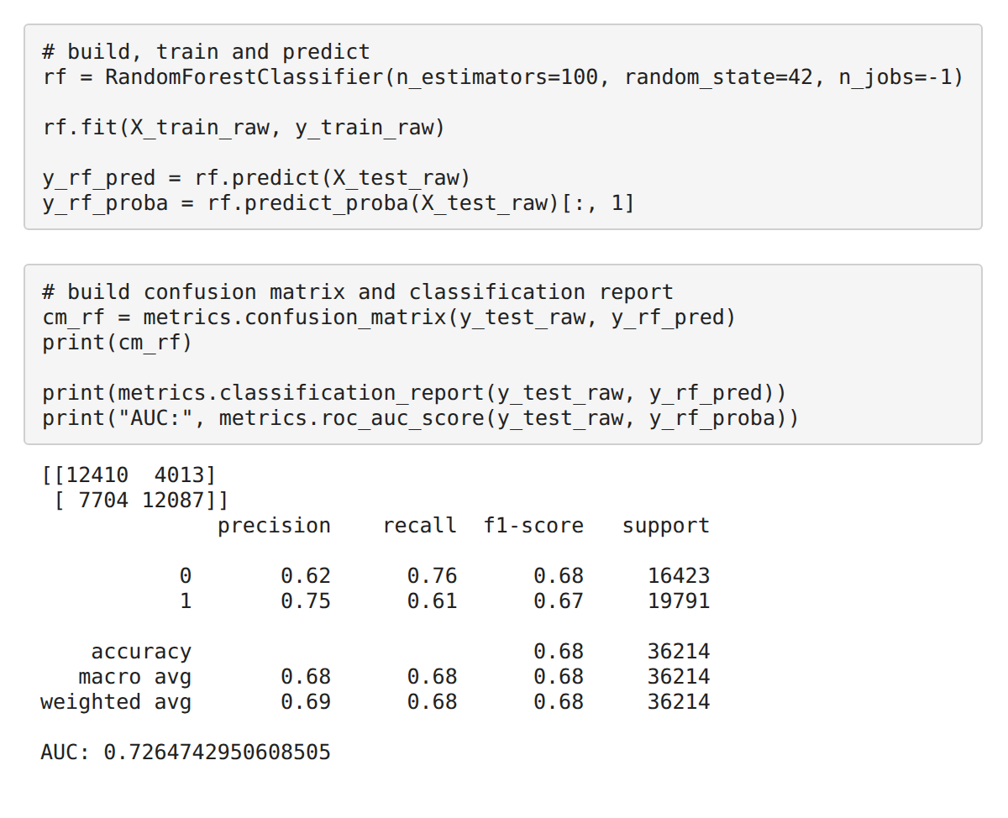 | 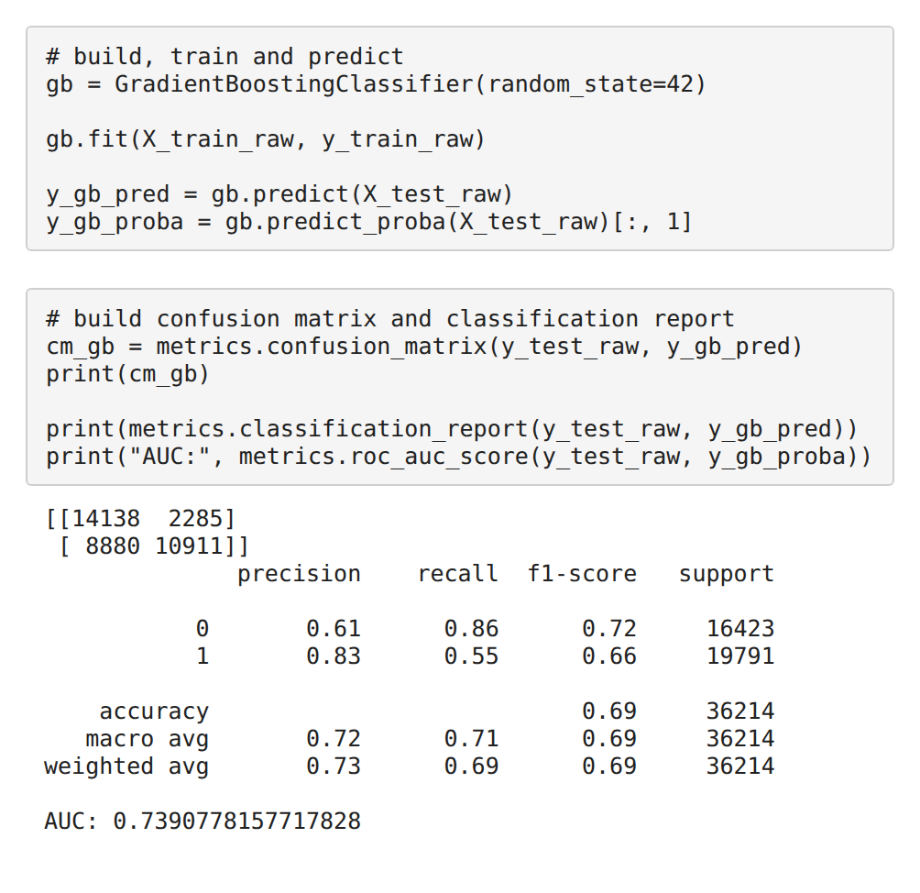

3.7 Initial Model Results
Model | Accuracy | Precision | Recall | F1-Score | AUC-ROC
Logistic Regression | 0.6904 | 0.8364 | 0.5389 | 0.6555 | 0.7355
Decision Tree | 0.6112 | 0.6444 | 0.6439 | 0.6442 | 0.6078
Random Forest | 0.6765 | 0.7507 | 0.6107 | 0.6735 | 0.7265
Gradient Boosting | 0.6917 | 0.8268 | 0.5513 | 0.6615 | 0.7391
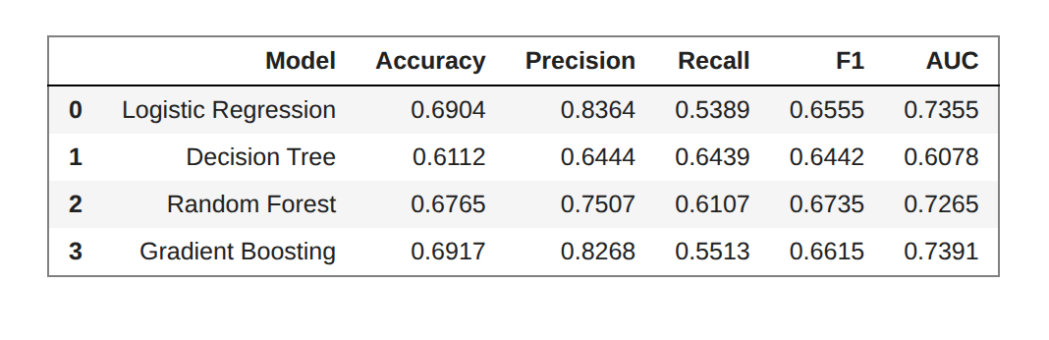

3.8 Interpretation of Initial Results
- Gradient Boosting has the highest AUC (0.7391) and highest accuracy (0.6917). Logistic Regression is very close (AUC 0.7355, accuracy 0.6904), so the margin is small.
- Random Forest has the highest F1 (0.6735) and a higher recall (0.6107) than Logistic Regression and Gradient Boosting, but its AUC is lower (0.7265).
- Decision Tree is the weakest model (AUC 0.6078). Its training accuracy was 1.00 against a test accuracy of 0.6112, which shows overfitting: it memorised the training orders. Its recall (0.6439) looks high, but it comes with low precision (0.6444) and many errors of both kinds.
- Precision vs recall: Logistic Regression and Gradient Boosting give careful alerts (precision above 0.82) but miss many late orders (recall about 0.54 to 0.55). Random Forest finds more late orders but raises more false alarms.
- AUC-ROC shows how well a model ranks risky orders above safe ones across all cut-offs. A model with a higher AUC gives better scores to build risk bands on.
Model | Late orders caught (TP) | False alarms (FP) | Late orders missed (FN)
Logistic Regression | 10,666 | 2,086 | 9,125
Decision Tree | 12,744 | 7,033 | 7,047
Random Forest | 12,087 | 4,013 | 7,704
Gradient Boosting | 10,911 | 2,285 | 8,880
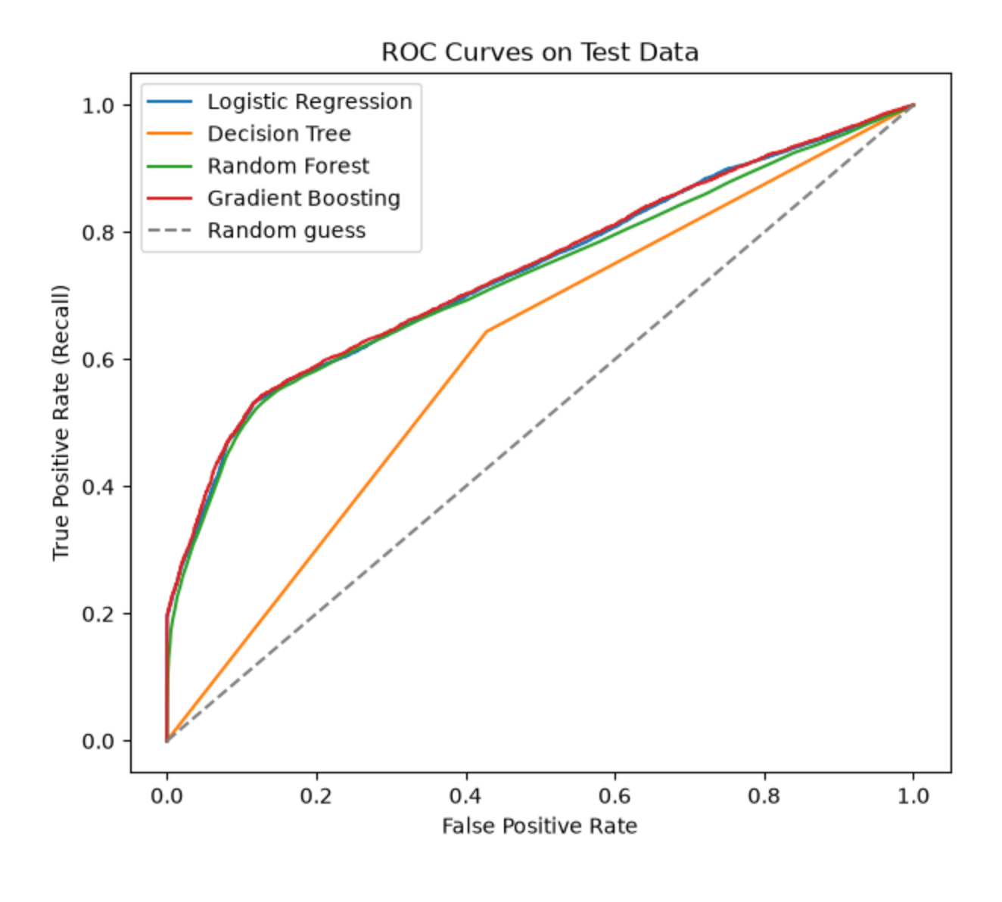
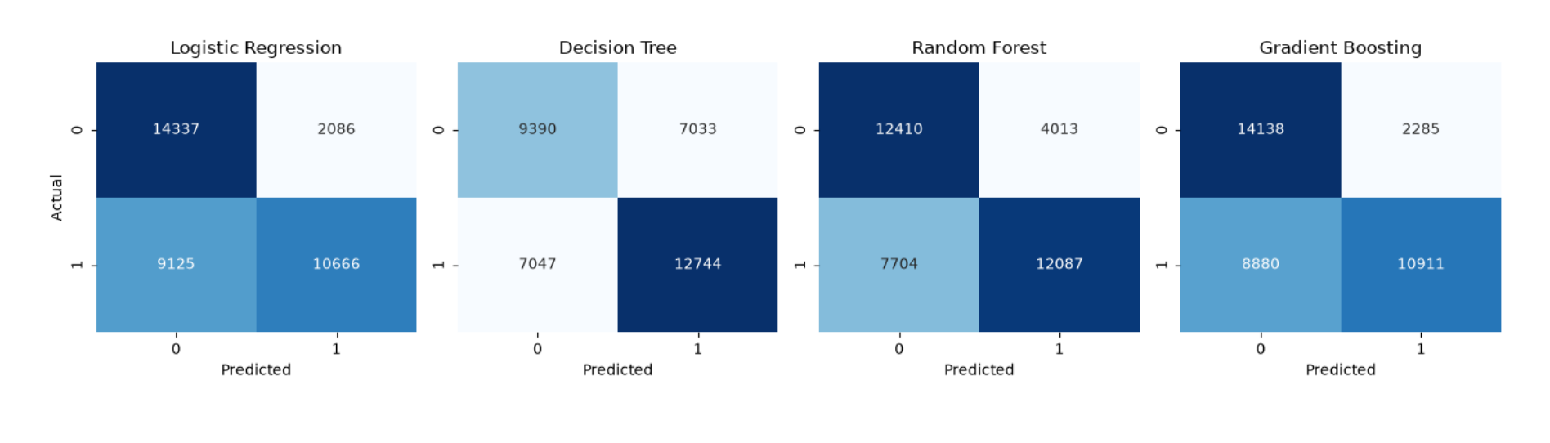

3.9 Model Selection for Further Refinement
Random Forest was trained on the training data only, so its feature importance could be used without touching the test data. The most important features were Shipping Mode_Standard Class (0.1492), Latitude (0.0996), Longitude (0.0944), order_day (0.0781) and Order Item Discount (0.0655). The top 20 features hold 84.13% of the total importance, and 79 of the 105 features have importance below 0.005. The notebook notes that a Random Forest tends to favour numeric columns with many different values, so the rank of Latitude, Longitude and order_day may be overstated. The top 20 features were kept for testing as a smaller model in Part 4.
Gradient Boosting was taken forward for refinement because it ranks risky orders best (highest AUC, 0.7391). The main thing to improve was recall. The Decision Tree (overfitting) and Random Forest were also checked with depth limits as a similar refinement test .

3.10 Part 3 Summary
- Target = Late_delivery_risk (binary). X = order-time features; the encoded data had 5,797 features.
- Train-test split was done by order ID (80/20): 144,305 training and 36,214 test observations, with a similar late share (54.87% and 54.65%).
- Features were reduced from 5,797 to 105 by removing high-cardinality and repeated columns. Random Forest importance then identified a top-20 set for Part 4.
- Four models were built: Logistic Regression, Decision Tree, Random Forest and Gradient Boosting.
- Initial results were close for three models (accuracy about 0.68 to 0.69, AUC 0.7265 to 0.7391); the Decision Tree overfitted (AUC 0.6078).
- Gradient Boosting (highest AUC) was taken forward for refinement, with recall as the main thing to improve.

PART 4 – MODEL EVALUATION & REFINEMENT

4.1 Objective
Part 4 evaluates the four models using classification metrics suited to the business problem, and then refines the modelling approach step by step. The business question is: which model should DataCo trust, and can it be made better?

4.2 Model Evaluation Metrics
The late class (1) is the focus. In the test data, a model that calls every order "late" would already be right about 55% of the time, so accuracy alone can be misleading.
Metric | Simple definition | Why it matters for late-delivery risk
Accuracy | Share of all orders predicted correctly. | Gives an overall picture, but with a 55/45 split it can look acceptable even for a weak model.
Precision | Of the orders flagged as late, how many were really late. | Low precision means the team spends effort on orders that would have been fine (false alarms).
Recall | Of the orders that were really late, how many the model caught. | Low recall means late orders slip through with no warning. This is the main business concern.
F1-Score | A balance of precision and recall. | Useful when we want one number that does not reward only precision or only recall.
AUC-ROC | How well the model ranks risky orders above safe ones across all cut-offs. | Important for a risk-scoring system, because the company can choose its own cut-off later.
Confusion Matrix | A table of correct and wrong predictions: TP, TN, FP, FN. | Shows exactly how many late orders were caught or missed and how many false alarms were raised.

4.3 Initial Model Comparison
Model | Accuracy | Precision | Recall | F1-Score | AUC-ROC
Logistic Regression | 0.6904 | 0.8364 | 0.5389 | 0.6555 | 0.7355
Decision Tree | 0.6112 | 0.6444 | 0.6439 | 0.6442 | 0.6078
Random Forest | 0.6765 | 0.7507 | 0.6107 | 0.6735 | 0.7265
Gradient Boosting | 0.6917 | 0.8268 | 0.5513 | 0.6615 | 0.7391

4.4 Interpretation of Initial Performance
- Better performers: Gradient Boosting (AUC 0.7391, accuracy 0.6917) and Logistic Regression (AUC 0.7355, accuracy 0.6904). Weaker: the Decision Tree (AUC 0.6078), followed by Random Forest on AUC (0.7265).
- Accuracy alone is not enough. Three very different models end near 0.69 accuracy, which is only moderately above the 55% obtained by calling every order late. Looking at the late class shows the real difference: Logistic Regression and Gradient Boosting have high precision (0.8364 and 0.8268) but low recall (0.5389 and 0.5513), while Random Forest trades precision (0.7507) for higher recall (0.6107).
- F1 and AUC give a fairer picture than accuracy: Random Forest has the highest F1 (0.6735), but Gradient Boosting has the highest AUC (0.7391), which matters most for ranking orders by risk.
- Reading from the notebook: when three different algorithms reach about the same score, the limit usually comes from the information in the data and not from the algorithm.

4.5 Model Refinement
Trying many versions and choosing the best by test score would make the test set no longer "unseen". So a validation set was cut out of the training orders. All versions were compared on validation data, and the test set was used only once at the end.
Refinement | Values tried | Model
Hyperparameter tuning – max_depth | 3, 5, 8, 12 | Decision Tree
Hyperparameter tuning – max_depth | 5, 10, 15, 20 | Random Forest
Feature reduction – top 20 features | 105 → 20 features | Gradient Boosting
Hyperparameter tuning – max_depth | 2, 3, 4, 5 | Gradient Boosting
Classification threshold (cut-off) | 0.30, 0.35, 0.40, 0.45, 0.50 | Gradient Boosting
Validation set | Sub-train 115,231 / validation 29,074 | All versions
Cross-validation, a wider search of settings, SMOTE and class weights were not used (the notebook notes this in its limitations).

4.6 Decision Tree Refinement
- What was changed: max_depth was limited. Depths 3, 5, 8 and 12 were tried on the validation set; the original tree had no depth limit.
- Why: train accuracy 1.00 against test accuracy 0.61 showed overfitting.
- Decision: depth 5 was retained. It had the highest AUC (0.7381) and F1 (0.6758) among the depths tried; depth 3 had slightly higher accuracy (0.6966).
max_depth | AUC | F1 | Accuracy
3 | 0.7377 | 0.6690 | 0.6966
5 | 0.7381 | 0.6758 | 0.6955
8 | 0.7285 | 0.6714 | 0.6865
12 | 0.7148 | 0.6674 | 0.6793

Version | Accuracy | Precision | Recall | F1-Score | AUC-ROC
DT v1 – default (no depth limit) | 0.6156 | 0.6538 | 0.6512 | 0.6525 | 0.6112
DT v2 – max_depth = 5 | 0.6955 | 0.8242 | 0.5726 | 0.6758 | 0.7381
This was the biggest gain in the project, and it came from fixing overfitting. Precision rose while recall fell, so the tree became more cautious in its alerts.

4.7 Random Forest Refinement
- What was changed: max_depth was limited. Depths 5, 10, 15 and 20 were tried; the original forest had no depth limit.
- Why: the same overfitting check as for the Decision Tree.
- Decision: depth 20 was retained because it gave the highest AUC (0.7360). The gain was small. Recall went down a little.

max_depth | AUC | F1 | Accuracy
5 | 0.7218 | 0.6836 | 0.6886
10 | 0.7269 | 0.6812 | 0.6931
15 | 0.7352 | 0.6814 | 0.6945
20 | 0.7360 | 0.6811 | 0.6934

Version | Accuracy | Precision | Recall | F1-Score | AUC-ROC
RF v1 – default | 0.6814 | 0.7572 | 0.6257 | 0.6852 | 0.7315
RF v2 – max_depth = 20 | 0.6934 | 0.8042 | 0.5906 | 0.6811 | 0.7360

4.8 Gradient Boosting Refinement
- Version 2 – feature reduction: only the top 20 features were used instead of all 105. The score stayed the same (see Table 4.9), so the smaller model was kept.
- Version 3 – depth tuning: max_depth values 2, 3, 4 and 5 were tried on the top-20 model to check whether simpler or deeper trees do better. The best AUC was at depth 3, which is already the default, so Version 3 is the same model as Version 2. Tuning did not improve the model.
- Version 4 – threshold change: see Section 4.10.
max_depth | AUC | F1 | Accuracy
2 | 0.7416 | 0.6749 | 0.6955
3 | 0.7418 | 0.6741 | 0.6963
4 | 0.7400 | 0.6720 | 0.6953
5 | 0.7385 | 0.6727 | 0.6942
Table 4.9: Gradient Boosting versions 1 to 3 (validation data)
Version | Accuracy | Precision | Recall | F1-Score | AUC-ROC
GB v1 – default, all 105 features | 0.6966 | 0.8320 | 0.5672 | 0.6745 | 0.7406
GB v2 – top 20 features | 0.6963 | 0.8317 | 0.5667 | 0.6741 | 0.7418
GB v3 – top 20 + depth tuned (depth 3) | 0.6963 | 0.8317 | 0.5667 | 0.6741 | 0.7418

4.9 Feature Selection Refinement
The feature set was reduced from 105 features to the top 20. Of the 105 features, 79 had Random Forest importance below 0.005, and the top 20 held 84.13% of total importance. On validation data the smaller model scored the same as the full model (AUC 0.7406 -0.7418, accuracy 0.6966 - 0.6963). On test data, the final 20-feature model gave AUC 0.7388 and accuracy 0.6915 against 0.7391 and 0.6917 for the 105-feature first version.
So feature reduction did not raise performance. It kept performance the same with a much smaller model. This helps because it:
- reduces unnecessary complexity (20 inputs instead of 105);
- improves interpretability, since the team only needs to track a few variables;
- reduces noise from features that add almost nothing; and
- makes the model more practical to run and to explain to the operations team.
The 20 features kept were: Shipping Mode_Standard Class, Latitude, Longitude, order_day, Order Item Discount, Order Item Discount Rate, order_weekday, order_month, Sales, Shipping Mode_Second Class, Product Price, Order Item Quantity, Shipping Mode_Same Day, order_year, Customer Segment_Corporate, Customer Segment_Home Office, Customer Country_Puerto Rico, Type_DEBIT, Type_TRANSFER and Type_PAYMENT.

4.10 Classification Threshold Refinement
- Original threshold: 0.50 (an order is flagged as late when the predicted probability is 0.50 or more).
- Revised threshold tested: 0.40, chosen from cut-offs 0.30 to 0.50 tried on the Version 3 probabilities (validation data).
- Why it was considered: recall for late orders was only about 0.57. The business wants to catch late orders before they happen, and a lower cut-off flags more orders, so recall goes up and precision goes down

Cut-off | Precision | Recall | F1 | Orders flagged %
0.30 | 0.5556 | 0.9939 | 0.7128 | 99.1
0.35 | 0.5824 | 0.9219 | 0.7138 | 87.7
0.40 | 0.6846 | 0.7158 | 0.6999 | 57.9
0.45 | 0.8151 | 0.5829 | 0.6797 | 39.6
0.50 | 0.8317 | 0.5667 | 0.6741 | 37.8

At 0.30 and 0.35 almost every order is flagged (99.1% and 87.7%), which would leave the operations team little to prioritise. At 0.40, recall rose from 0.5667 to 0.7158, precision fell from 0.8317 to 0.6846 and accuracy fell from 0.6963 to 0.6597, with 57.9% of orders flagged instead of 37.8%. This is Version 4: the same model as Version 3 with a lower cut-off. The AUC does not change, because only the cut-off was changed.
Business reason: the cut-off does not make the model better; it is a business trade-off between missed late orders and false alarms. There is no single correct cut-off without knowing the cost of each. If the action is cheap (an advance message to the customer, an extra check), 0.40 makes sense. If the action is costly (upgrading a shipment, pulling warehouse staff), 0.50 is safer.
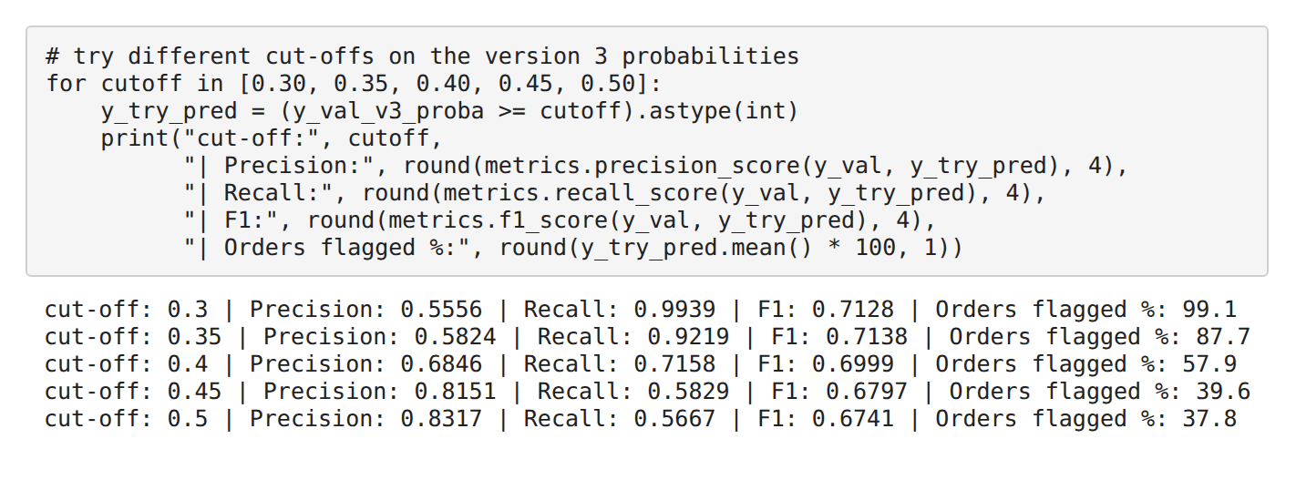

4.11 Validation and Final Testing
- Why a validation set: several versions were compared. Choosing among them using the test score would make the test set "seen" and the final score optimistic.
- How it was used: the 144,305 training observations were split again (80/20, by order ID) into 115,231 sub-train and 29,074 validation observations. All versions (DT, RF and GB) were trained on sub-train and compared on validation.
- Final testing: the chosen version (Gradient Boosting, top 20 features, max_depth = 3) was trained once more on the full 144,305 training observations and checked on the 36,214 test observations, which no version had seen during refinement. The test set was used only for this final, unbiased evaluation.
- Consistency check: AUC was 0.7418 on validation and 0.7388 on test, so the choices made during refinement hold on unseen orders.

4.12 Model Version Tracking
Model Version | Change Made | Reason | Result / Performance Change | Decision
DT v1 | Default settings, no depth limit | Baseline | Acc 0.6156, AUC 0.6112; train accuracy 1.00 vs test 0.61 | Overfitting – refine
DT v2 | max_depth limited to 5 (was unlimited) | Overfitting check | AUC 0.6112 → 0.7381; accuracy 0.6156 → 0.6955 | Improved – retained
RF v1 | Default settings, no depth limit | Baseline | Acc 0.6814, AUC 0.7315 | Refine
RF v2 | max_depth limited to 20 (was unlimited) | Same overfitting check as DT | AUC 0.7315 → 0.7360; accuracy 0.6814 → 0.6934; recall 0.6257 → 0.5906 | Small gain – retained
GB v1 | Default settings, all 105 features | Baseline for refinement | Acc 0.6966, AUC 0.7406 | Baseline
GB v2 | Only top 20 features used (was 105) | 79 of 105 features had importance below 0.005 | AUC 0.7406 → 0.7418; accuracy 0.6966 → 0.6963 | Same score, simpler model – retained
GB v3 | max_depth tried at 2, 3, 4, 5 | Check if simpler or deeper trees do better | Best depth was 3 (already the default); same as v2 | No improvement – depth 3 kept
GB v4 | Cut-off lowered from 0.50 to 0.40 | Recall was only about 0.57 | Recall 0.5667 → 0.7158; precision 0.8317 → 0.6846; accuracy 0.6963 → 0.6597 | Trade-off – business choice
GB final (test data) | GB v3 settings trained on full training data | Final unbiased check | AUC 0.7388, accuracy 0.6915 (cut-off 0.50); see Table 4.12 | Final model

4.13 Role of GenAI in Model Refinement
GenAI was used as a decision-support and review tool during refinement. It was used to:
- review possible model refinements (for example, limiting tree depth);
- discuss feature-selection approaches (for example, whether it is safe to retrain with only the top features, and how to check);
- suggest possible tuning directions (for example, which Gradient Boosting setting to tune first); and
- help interpret the precision/recall trade-off (for example, how to catch more late orders without retraining).
GenAI did not produce or select the final model. The project team ran every suggestion in the notebook, compared the results on the validation set using the dataset, the assignment requirements and model performance, and then decided what to keep. For example, depth tuning of Gradient Boosting was suggested but not retained as an improvement, because the results showed no gain. The five prompts that led to refinement steps are listed in the version log of the notebook (Decision Tree overfitting, Random Forest depth, top-feature retraining, Gradient Boosting tuning and the precision/recall cut-off).

4.14 Final Model Selection
Final model: Gradient Boosting with the top 20 features and max_depth = 3 (Version 3 settings, trained on the full training data and evaluated once on the test data).

Final Model | Features | Accuracy | Precision | Recall | F1-Score | AUC-ROC
Gradient Boosting – first version (Section 3.7), for reference | 105 | 0.6917 | 0.8268 | 0.5513 | 0.6615 | 0.7391
Gradient Boosting – final, cut-off 0.50 | 20 | 0.6915 | 0.8258 | 0.5518 | 0.6616 | 0.7388
Gradient Boosting – final, cut-off 0.40 | 20 | 0.6549 | 0.6782 | 0.7013 | 0.6896 | 0.7388

Why this model was selected:
- Performance: it has the highest AUC among the four models in the initial comparison (0.7391), and the final 20-feature version keeps almost the same scores (AUC 0.7388, accuracy 0.6915). The edge over Logistic Regression is small.
- Business objective: the aim is a risk score for each order, and AUC measures how well orders are ranked by risk. The score also lets the company choose its own cut-off.
- Precision/recall trade-off: at cut-off 0.50 the model gives careful alerts (precision 0.8258) but misses many late orders (recall 0.5518). At cut-off 0.40, recall rises to 0.7013 and precision falls to 0.6782. The notebook leaves the choice to the business, as it depends on the cost of a missed late order against the cost of a false alarm. The risk bands in Part 5 use 0.40 as the lower limit of the Medium band.
- Interpretability and practicality: 20 inputs instead of 105 make the model easier to explain, monitor and run.
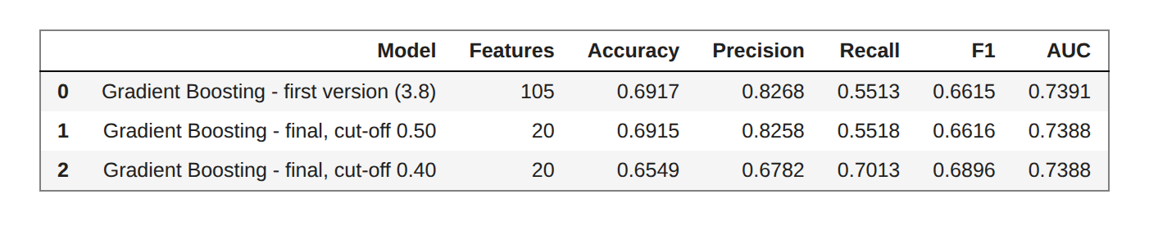

4.15 Confusion Matrix Interpretation
In this project, "positive" means a late order (class 1).
 | Cut-off 0.50 | Cut-off 0.40
True Positives (late, flagged late) | 10,921 | 13,880
True Negatives (on time, not flagged) | 14,120 | 9,838
False Positives (on time, flagged late) | 2,303 | 6,585
False Negatives (late, not flagged) | 8,870 | 5,911

- True Positives: late orders correctly warned. At cut-off 0.50 the model catches 10,921 of the 19,791 late orders; at 0.40 it catches 13,880.
- True Negatives: on-time orders correctly left alone (14,120 at 0.50; 9,838 at 0.40).
- False Positives: on-time orders wrongly flagged. Business meaning: wasted effort, such as priority handling or customer messages that were not needed. There are 2,303 at 0.50 and 6,585 at 0.40.
- False Negatives: late orders with no warning. Business meaning: the customer receives a late delivery without any advance notice, and the company has no chance to act. There are 8,870 at 0.50 (about 45% of late orders) and 5,911 at 0.40.
Lowering the cut-off from 0.50 to 0.40 converts about 2,959 missed late orders into caught ones, but adds about 4,282 false alarms. Whether this is worthwhile depends on how costly each action is.
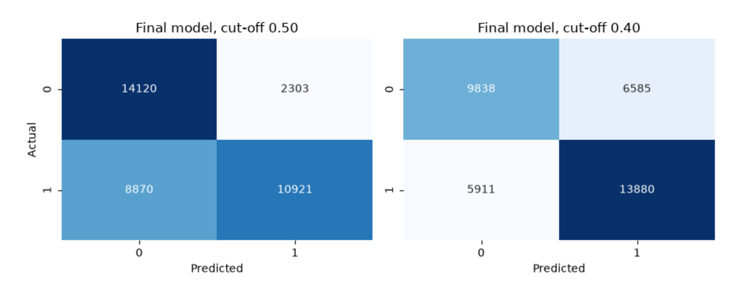

4.16 Key Findings from Model Evaluation
- Gradient Boosting had the highest AUC (0.7391) and accuracy (0.6917) among the four initial models, but Logistic Regression was very close (0.7355 and 0.6904).
- The Decision Tree overfitted (train accuracy 1.00, test accuracy 0.6112). Limiting depth to 5 raised validation AUC from 0.6112 to 0.7381, the biggest gain in the project.
- After refinement, every tree-based model reached an AUC of about 0.74. Refinement removed overfitting and simplified the model, but did not make predictions better.
- Reducing features from 105 to 20 kept the same performance (test AUC 0.7388 against 0.7391), so the smaller model was chosen.
- Depth tuning of Gradient Boosting gave no improvement; the best depth (3) is the default.
- Changing the cut-off from 0.50 to 0.40 raised test recall from 0.5518 to 0.7013 but reduced precision from 0.8258 to 0.6782. This is a business trade-off, not a better model.
- Validation and test AUC agree (0.7418 and 0.7388), so the refinement choices hold on unseen orders.

4.17 Part 4 Conclusion
Part 4 showed that accuracy alone is not enough: the late class must be judged on precision, recall, F1 and AUC. Gradient Boosting was taken forward for refinement because it ranked risky orders best. Using a validation set, tree depth was limited, the feature set was cut from 105 to 20 and the cut-off was tested. The result was a simpler model with the same predictive power (AUC 0.7388 on test data), not a more powerful one. The final model, Gradient Boosting with 20 features and max_depth = 3, was selected for its AUC, its use as a risk-scoring tool and its practicality. The cut-off remains a business decision between catching more late orders and avoiding false alarms.

PART 5 – BUSINESS FINDINGS & FINAL SOLUTION

5.1 Objective
Part 5 converts the model results into practical insights and recommendations for DataCo, a supply-chain company. Each finding follows the pattern Finding - Evidence - Interpretation - Action.

5.2 Important Features
Feature importance of the final Gradient Boosting model (20 features) is shown below. The notebook also reports Random Forest importance in Section 3.9 for comparison.
Rank | Feature | Importance
1 | Shipping Mode_Standard Class | 0.7426
2 | Shipping Mode_Same Day | 0.1288
3 | Shipping Mode_Second Class | 0.0623
4 | Type_TRANSFER (payment by transfer) | 0.0363
5 | Latitude | 0.0109
6 | Longitude | 0.0073
7 | order_day | 0.0056
8 | order_month | 0.0015
9 | order_year | 0.0014
10 | Customer Segment_Corporate | 0.0011

- The three shipping mode columns together hold 93.38% of the importance. First Class is the dropped reference category, so it is represented by the other shipping mode columns being 0.
- Type_TRANSFER is next (about 3.6%). Latitude, Longitude and order_day together are about 2.4%.
- The remaining features (ranks 11 to 20, including product price, sales, discount and quantity) each have importance of 0.0009 or less.
- In the Random Forest (Section 3.9), Latitude, Longitude and order_day ranked high, but in the final model they are close to zero. This supports the caution that Random Forest may overstate numeric columns with many values.
Important: feature importance shows what the model uses to separate late from on-time orders. It is not proof of cause
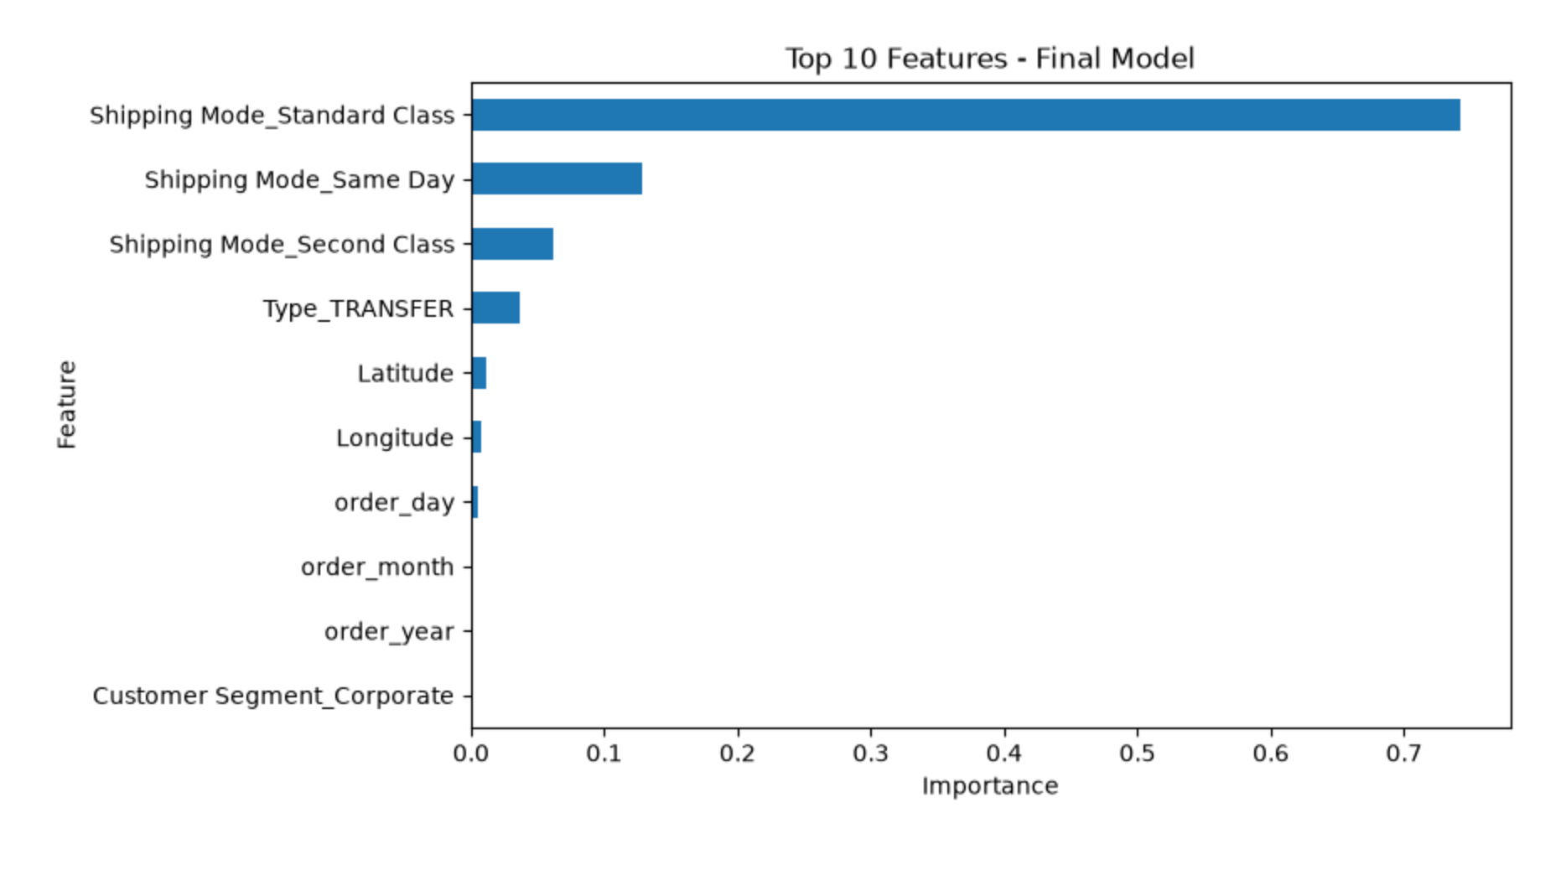

5.3 Business Interpretation of Important Features
- Shipping mode: the prediction is driven almost entirely by shipping mode. In practical terms, delivery risk is mostly a question of which shipping mode the order uses. In the test data, 94.9% of First Class and 76.4% of Second Class orders were late, against 38.3% for Standard Class and 45.3% for Same Day. A likely reason is that the delivery promises of the faster modes are too tight, but this has not been proven and should be checked with the operations team.
- Payment by transfer: Type_TRANSFER is the only non-shipping feature with visible importance. In Part 2, transfer orders were late 48.5% of the time against about 57% for the other payment types. The reason is unknown and needs investigation; the model does not show that payment type causes lateness.
- Location and order date: Latitude, Longitude and order_day have small importance in the final model. They add little compared with shipping mode.
- Customer segment, market, product category and month: none reached meaningful importance in the final model, which suggests these are weak signals for late delivery in this dataset.

5.4 Key Business Findings
- EDA (Part 2): about 55% of orders are late (54.83% overall), so late delivery is a regular problem and not a rare event. Shipping mode showed by far the biggest gap in late rate. Customer segment, market, product category and month had late rates close to the overall average
- Model results: the final Gradient Boosting model has AUC 0.7388 and accuracy 0.6915 on test data. Performance is moderate.
- Feature importance: shipping mode holds 93.38% of the importance, followed by payment by transfer (about 3.6%).
- Model vs simple rule: at cut-off 0.50, the model is hardly different from the simple rule "First Class or Second Class = late, everything else = not late" (Table 5.2). With the information available at order time, the model has mostly learned the shipping mode rule. What the model adds is a score for every order, so the company can choose its own cut-off (at 0.40, recall rises to 0.7013) and rank orders by risk.
Approach | Accuracy | Precision | Recall | F1-Score
Simple shipping mode rule | 0.6916 | 0.8460 | 0.5327 | 0.6538
Final model, cut-off 0.50 | 0.6915 | 0.8258 | 0.5518 | 0.6616
Final model, cut-off 0.40 | 0.6549 | 0.6782 | 0.7013 | 0.6896

- Delivery-risk analysis: the High risk band is a reliable warning list (84.4% of High-band orders were really late). Standard Class is the biggest group (21,633 of 36,214 test orders, 38.3% late). That is about 8,300 late orders, roughly 42% of all late orders in the test data, and the model cannot tell which of them will be late.

5.5 Business Recommendations
# | Recommendation | Evidence from the project
1 | Review the delivery promise for First Class and Second Class (operational review). Either give a realistic number of days or add capacity for these modes. | 94.9% of First Class and 76.4% of Second Class test orders were late. Shipping mode holds 93.38% of the model's importance.
2 | Use the High risk band as an early-warning list. Give these orders priority in the warehouse and tell the customer a realistic date in advance. | 84.4% of High-band orders were really late.
3 | Do not expect the model to pick out late Standard Class orders yet. Collect more information for them first. | Standard Class is late 38.3% of the time and holds about 42% of all late orders, but its orders fall in the Low and Medium bands (37.5% and 41.7% late).
4 | Find out why orders paid by transfer are late less often (transfer/payment-related risk). | Type_TRANSFER has about 3.6% importance. In Part 2, transfer orders were late 48.5% of the time against about 57% for other payment types.
5 | Do not build separate plans by customer segment, market, product category or month. | None reached meaningful importance, and Part 2 showed their late rates are close to the overall average.

Recommendation 1 does not need a model at all: when almost every order of a shipping mode is late, the promise itself is the problem. The model should also be monitored and retrained from time to time, especially if delivery promises are changed, because the main pattern it has learned would then change.

5.6 Proposed Deployable Solution
The final model can be used as an early-warning system. For each new order it gives a risk score (probability of late delivery between 0 and 1), which is converted into a risk band. The 0.40 and 0.60 band limits were chosen by judgement in the notebook, not from real cost data.

Risk band | Score | Suggested action | Orders | Share of orders | Actual late %
High | 0.60 and above | Priority picking and dispatch. Advance message to the customer with a realistic date. | 12,536 | 34.6% | 84.4%
Medium | 0.40 to below 0.60 | Watch list. Act only if the warehouse is under load that day. | 7,929 | 21.9% | 41.7%
Low | Below 0.40 | Normal process. | 15,749 | 43.5% | 37.5%

- Order-level risk prediction: every order gets a score at order placement.
- Operational alerts: High-band orders trigger alerts. This band is made up of all First Class orders (5,510) and almost all Second Class orders (6,939 of 6,952), plus 87 Same Day orders.
- Low and Medium bands are hard to tell apart (37.5% against 41.7% late). Standard Class orders fall in these bands (15,296 Low, 6,337 Medium).
- Scores are realistic at shipping-mode level: average predicted risk against actual late rate is First Class 93.9% vs 94.9%, Second Class 77.2% vs 76.4%, Same Day 46.7% vs 45.3% and Standard Class 38.2% vs 38.3%.
- Dashboard and monitoring: see Sections 5.7 and 5.8.
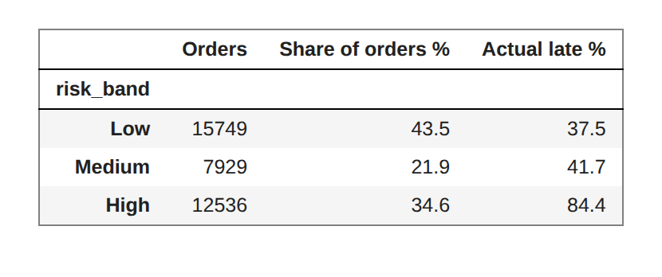

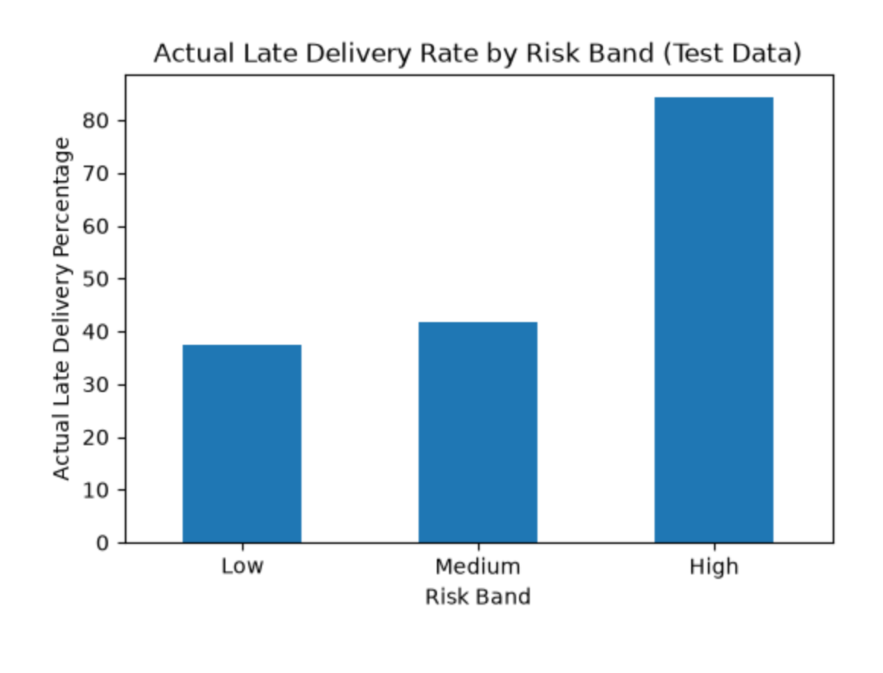
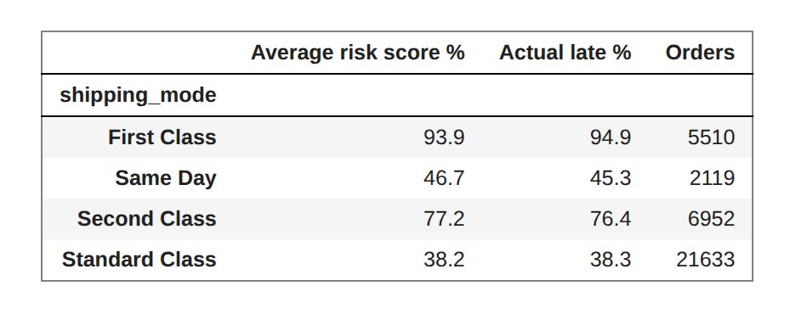
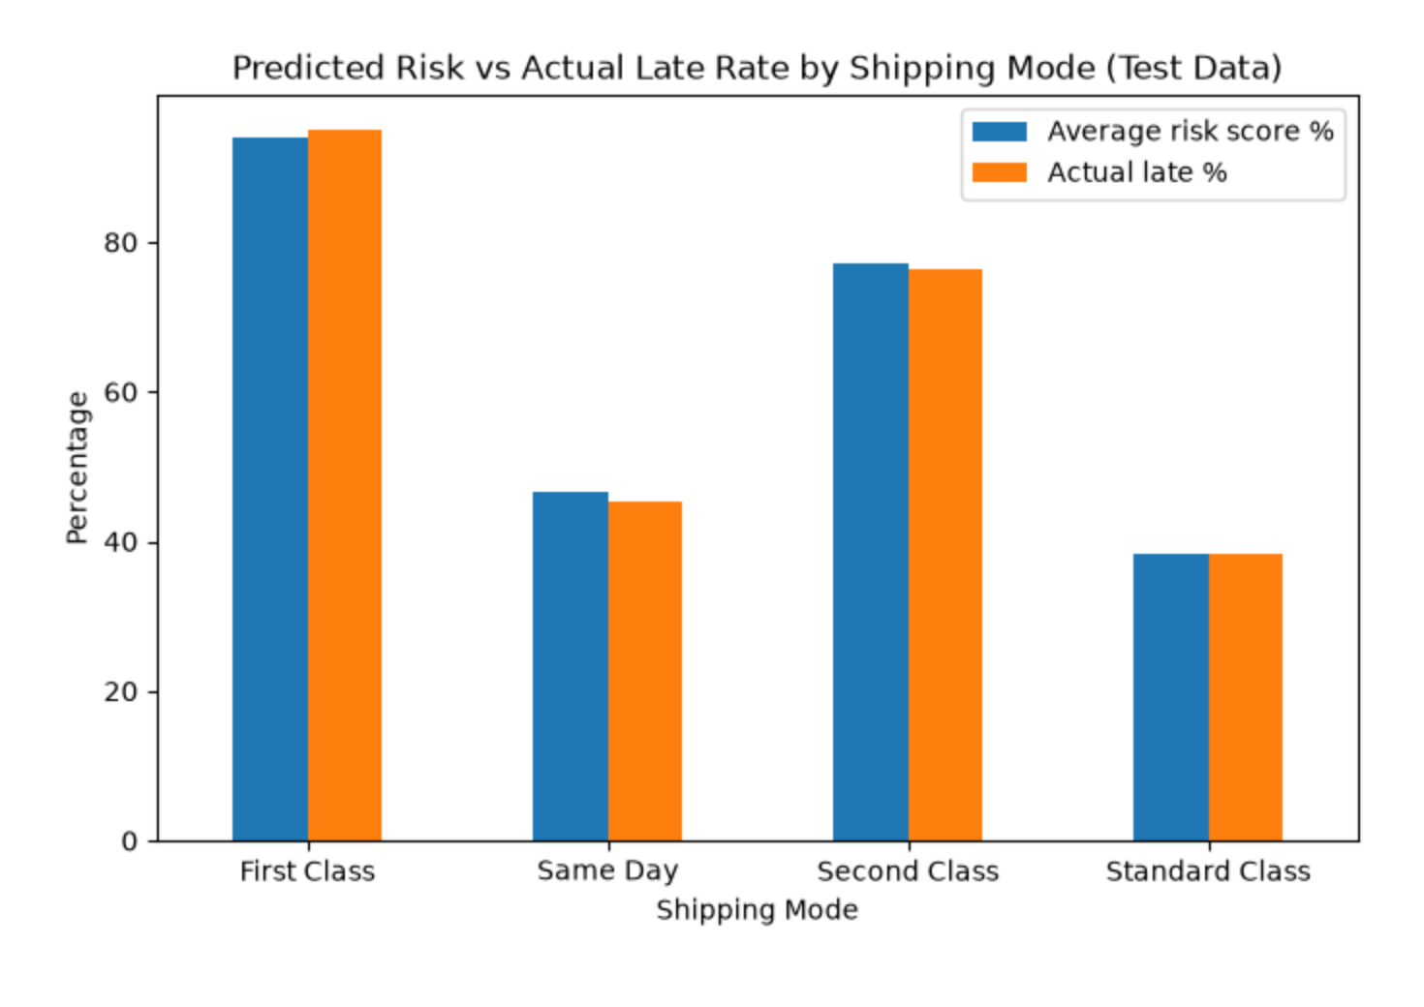

5.7 Suggested Dashboard / Business Intelligence View
The project proposes a dashboard for the operations team with the following elements:
- Number of open orders in each risk band, updated daily (risk-band distribution).
- Late rate by shipping mode and by order region (regional analysis).
- Predicted risk against actual late rate each month, to see whether the model still holds (predicted vs actual outcomes).
- Recall and precision of last month's alerts (precision/recall monitoring).

5.8 How the Company Can Use the Model
The model uses only the 20 features that are known when the order is placed (shipping mode, payment type, location, order date, price and discount fields, quantity and customer segment/country). No information that is known only after delivery is used, so there is no leakage in the live process.
- Step 1: An order is received.
- Step 2: The 20 order-time features are passed to the model.
- Step 3: The model generates a late-delivery risk score between 0 and 1.
- Step 4: The score is converted to a band; High-risk orders (0.60 and above) are flagged.
- Step 5: The operations team reviews the flagged orders (and the Medium watch list on heavy-load days).
- Step 6: Preventive action is taken, such as priority picking and dispatch and an advance message to the customer with a realistic date.
- Step 7: The actual delivery outcome is compared with the prediction.
- Step 8: Model performance (recall, precision, predicted vs actual late rate) is monitored over time, and the model is retrained when needed.

5.9 Limitations
- Moderate performance: accuracy is 0.69 and AUC is 0.74. At cut-off 0.50 the model misses about 45% of late orders (8,870 of 19,791). On accuracy it is no better than the simple shipping mode rule.
- Missing information: the data has nothing on carrier, warehouse workload, stock availability or delivery distance. These are likely reasons for delay, especially for Standard Class orders.
- Importance is not cause: the model shows that shipping mode separates late and on-time orders; it does not prove why.
- Time period: orders run from January 2015 to January 2018. The split was by order, not by time, so the model has not been tested on a later period than it was trained on.
- Small tuning search: only a few depth values were tried by hand, on one validation split. A wider search or cross-validation was not done.
- Cut-offs chosen by judgement: the 0.40 and 0.60 limits are not based on real costs, because the cost of a missed late order and of a false alarm are not known.
- Dropped detail: city, state, country and product name columns were removed to keep the model manageable. Some local patterns may have been lost.

5.10 Future Scope
- Add operational variables such as carrier information, warehouse workload/capacity and stock availability, and delivery distance, to help predict late Standard Class orders.
- Use a larger tuning search and cross-validation.
- Test the model on a later time period than the training period.
- Set the cut-offs and risk bands using actual costs of a missed late order and of a false alarm.
- Integrate the risk score into a live dashboard and monitor model performance over time, retraining after any change in delivery promises.

5.11 Part 5 Conclusion
The EDA showed that about 55% of orders are late and that shipping mode created by far the biggest gap in late rate. The machine learning model, a Gradient Boosting classifier with 20 features, confirmed this: shipping mode holds 93.38% of its importance, and the model reached AUC 0.7388. This led to practical recommendations: review the delivery promise for First Class and Second Class, act on the High risk band, collect more data for Standard Class and investigate the transfer-payment pattern. The model can be deployed as an early-warning risk score with High, Medium and Low bands, a monitoring dashboard and a feedback loop that compares predicted and actual outcomes. Its strongest value is that it shows clearly where the late-delivery problem sits and lets DataCo choose how many orders to flag.

PART 6 – CONCEPTUAL KNOWLEDGE

6.1 Types of Analytics
Table 6.1: Four types of analytics and this project
Type | Question answered | In this project
Descriptive Analytics | What happened? | EDA in Part 2: late-delivery share (about 55%), late rate by shipping mode, payment type and other groups.
Diagnostic Analytics | Why did it happen? | Comparing late rates across groups and using feature importance to see which factors are linked to late delivery (without claiming cause).
Predictive Analytics | What is likely to happen? | Classification models predicting the probability that an order will be late.
Prescriptive Analytics | What should we do? | Recommendations and risk-band actions, such as reviewing delivery promises and prioritising High-risk orders.

6.2 Exploratory Data Analysis
EDA means studying the data with summaries and charts before modelling, to understand distributions, relationships and unusual values. In this project EDA showed the late-delivery share, the large gap in late rate across shipping modes and which variables looked weak, and it guided cleaning and encoding.

6.3 Classification
Classification is a type of supervised learning in which a model learns from labelled data to predict a category. Here the categories are late (1) and not late (0), so it is binary classification. Logistic Regression, Decision Tree, Random Forest and Gradient Boosting were used. Most classifiers also give a probability, which can be used as a risk score.

6.4 Feature Selection
Feature selection means keeping the useful input variables and removing the rest. It reduces complexity and noise, speeds up training and makes the model easier to explain. In this project, features were reduced from 5,797 to 105 by removing high-cardinality and repeated columns, and then to the top 20 using Random Forest importance.

6.5 Model Evaluation
Model evaluation measures how well a model works on unseen data. Accuracy, precision, recall, F1-score, AUC-ROC and the confusion matrix (Section 4.2) were used. A separate validation set was used to compare versions, and the test set was used once at the end.

6.6 Overfitting and Underfitting
Overfitting means a model learns the training data too closely, including noise, and performs poorly on new data. Underfitting means the model is too simple to learn the real pattern. In this project the unlimited Decision Tree overfitted: training accuracy was 1.00 but test accuracy was 0.6112. Limiting its depth to 5 fixed this on validation data (accuracy 0.6156 → 0.6955).

6.7 Data Leakage
Data leakage happens when information that would not be available in real use, or information from the test data, enters the model's training. It makes results look better than they really are. In this project leakage was avoided by splitting by order ID (items of one order stay together), excluding Order Id from the features, fitting the scaler on training data only, and using only order-time information as features.

6.8 Python Libraries Used in Business Analytics
Table 6.2: Python libraries and their use in this project
Library | What it is used for | Use in this project
Pandas | Reading, cleaning, grouping and summarising table-type data in DataFrames. | Loading the DataCo data, handling df and df_model, cross-tabulations and risk-band summary tables.
NumPy | Fast numerical calculations on arrays; the base of Pandas and Scikit-learn. | Underlying numerical operations; Pandas and Scikit-learn run on NumPy arrays.
Matplotlib | Basic plotting of charts. | Bar charts of model comparison, ROC curves, feature importance and risk-band charts.
Seaborn | Statistical charts built on Matplotlib, with simpler code and cleaner styling. | Heatmaps of confusion matrices (and EDA charts, if used in Part 2).
Scikit-learn | Machine learning: data splitting, scaling, models and metrics. | train_test_split, StandardScaler, LogisticRegression, DecisionTreeClassifier, RandomForestClassifier, GradientBoostingClassifier and the metrics module (accuracy, precision, recall, F1, AUC, confusion matrix).

GITHUB Link
https://github.com/ShauryaSrivastava-1/Machine-Learning-Group-Project.git

